**Lab: EC2 Create & Connect**

**Services Used: EC2**

**Launching EC2 Instance:**

1. Go to EC2 Service

EC2 🡪 Instances 🡪 Launch Instance.

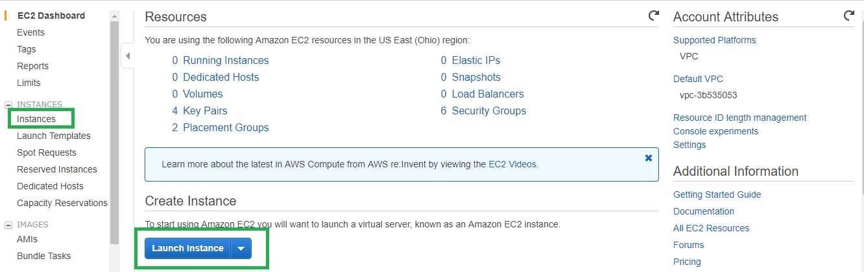

1. Select the AMI you want to launch. Ensure the AMI is under free tier to avoid being charged.

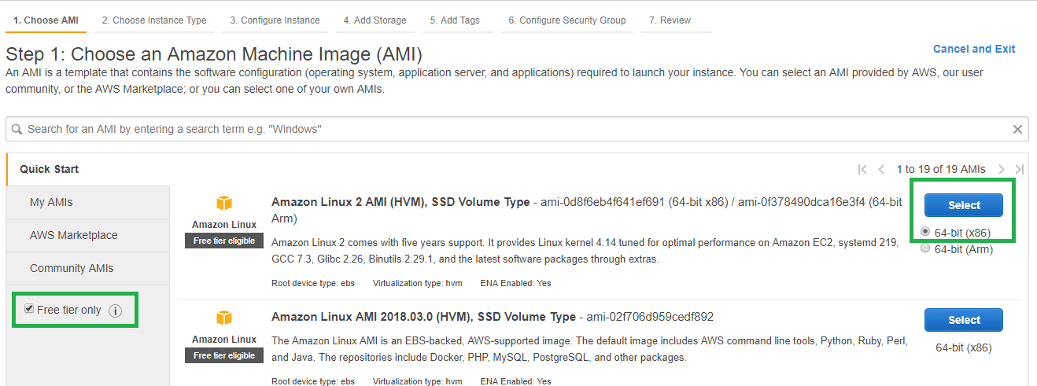

1. Select the Instance Type as t2.micro which is free tier eligible.

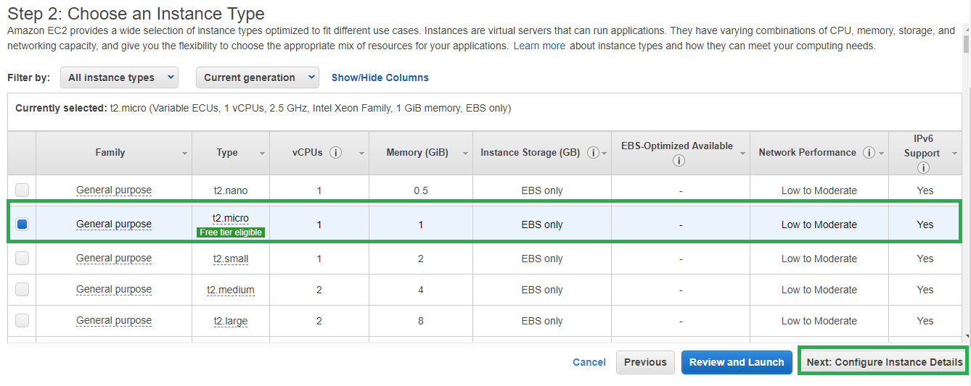

1. Provide all the instance configuration details. If you are launching EC2 in custom VPC ensure all the prerequisites are taken care to make the instance reachable in Internet.

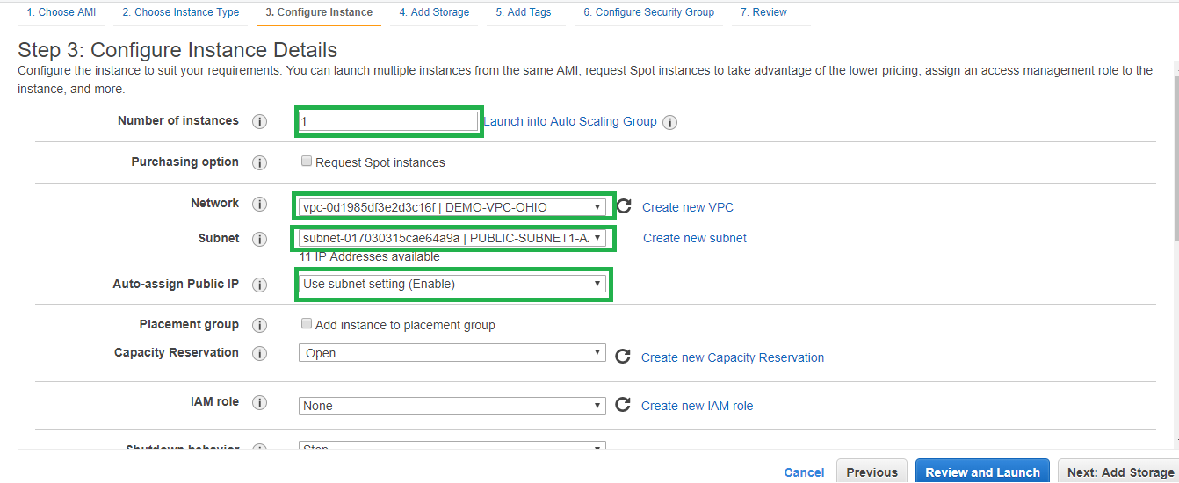

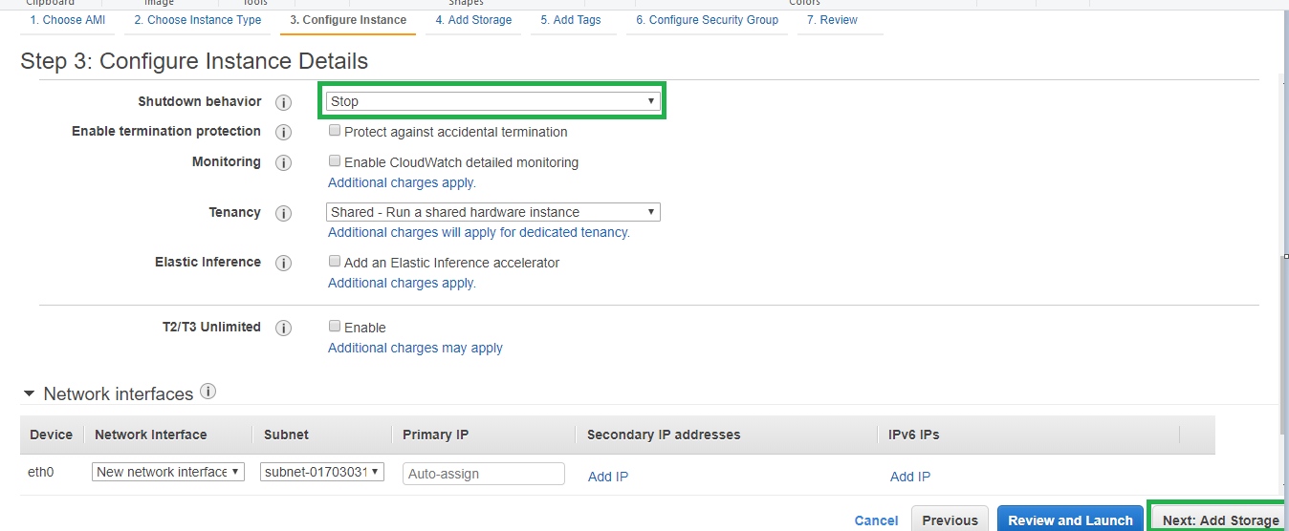

1. Provide the storage for the new instance. If you want to add any new disk mention here or it can be done later once the instance is launched also.

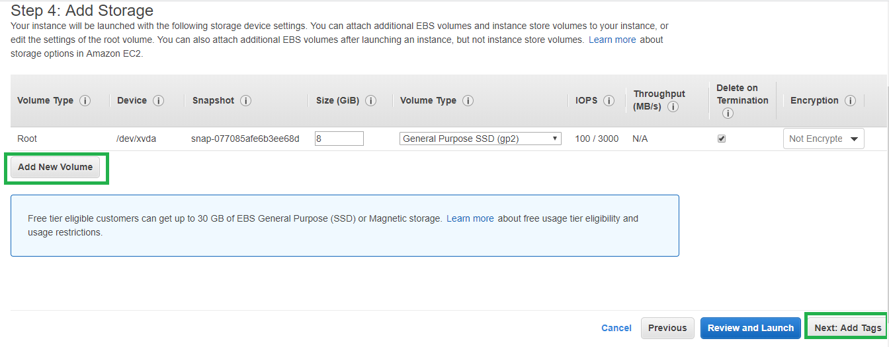

1. Add tags for the instance as per you requirement.

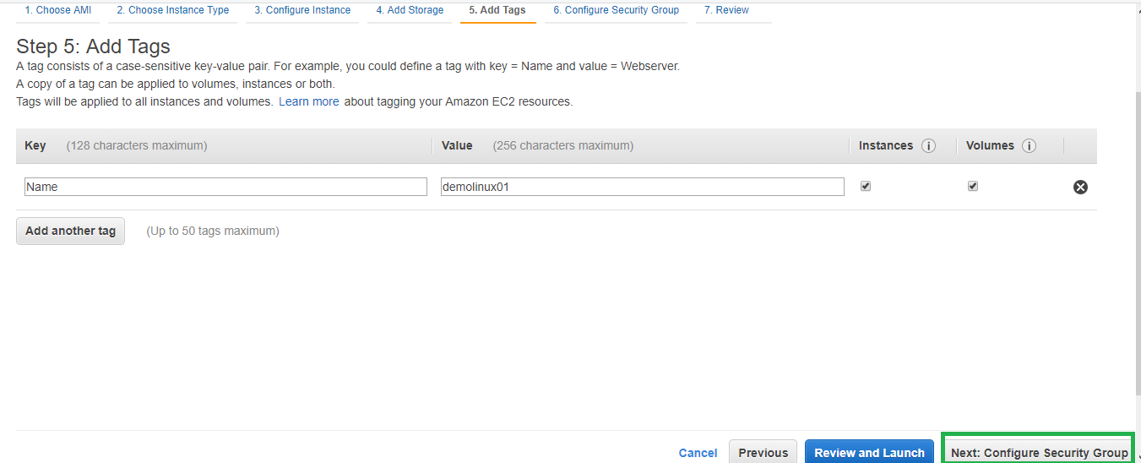

1. If you already have security group configured select that otherwise create new security group with all the required ports allowed. Minimum Inbound Ssh for UNIX and RDP for windows for connecting to the instance.

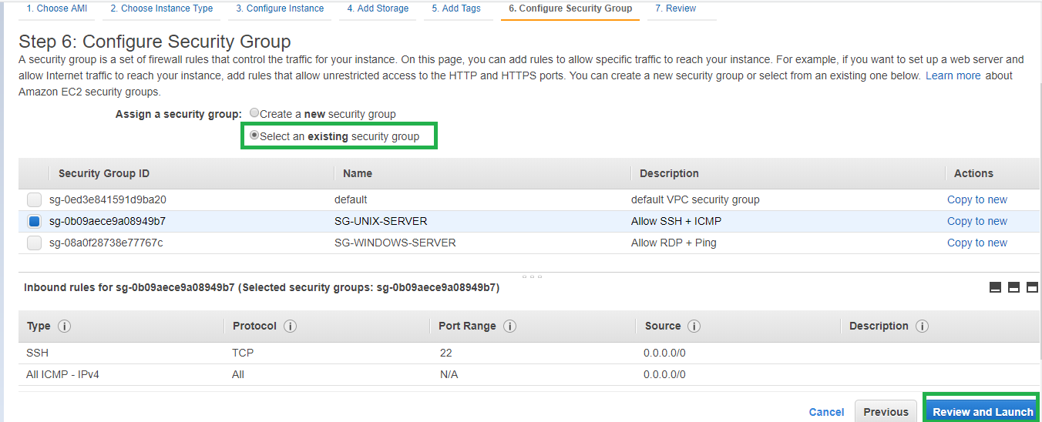

1. Review the instance configuration and proceed to Launch.

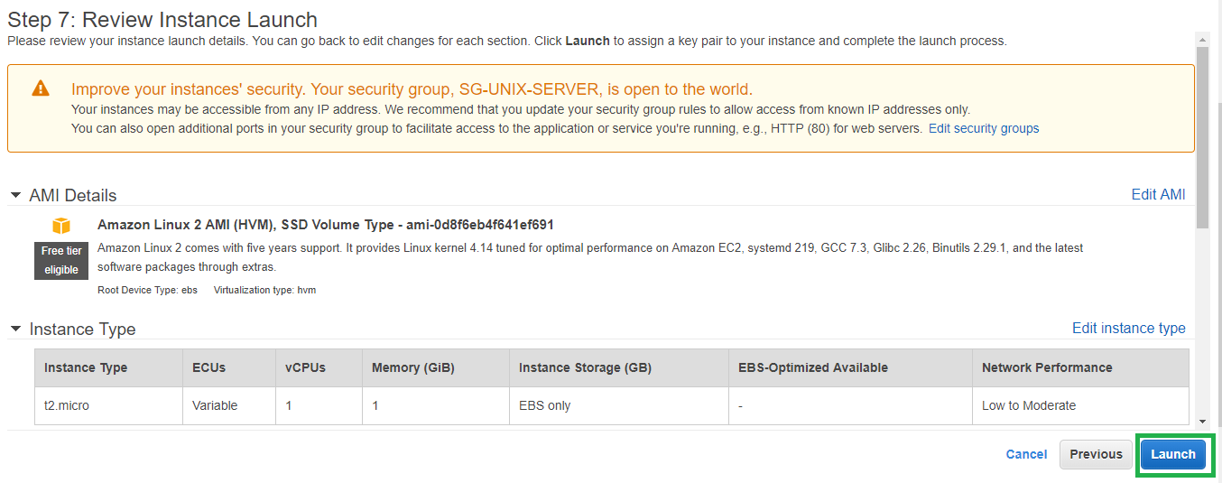

1. If you creating new key ensure to download. If you are using old key make sure you have it already downloaded to login to the instance once it is created.

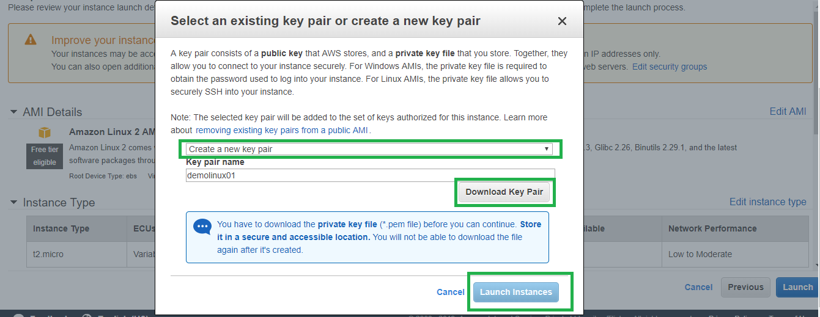

1. Verify the instance is now launched and in status running.

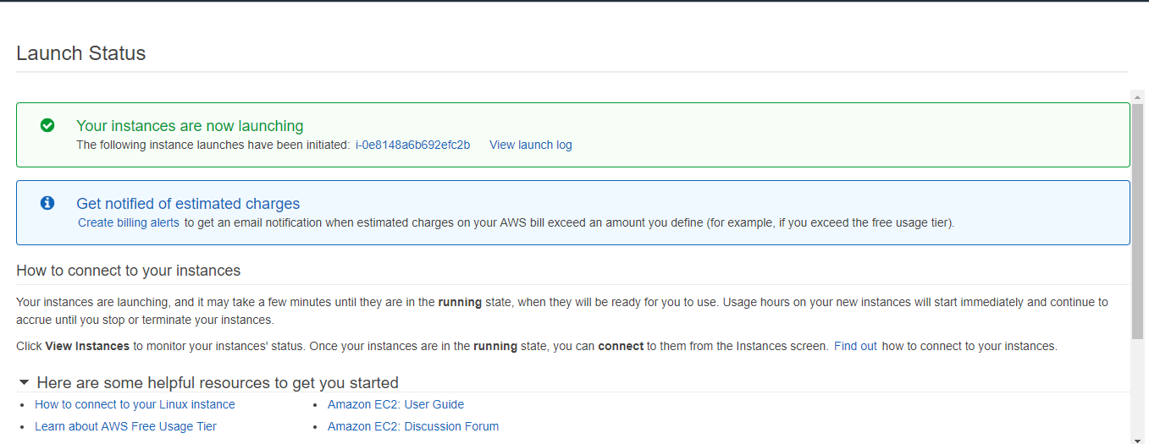

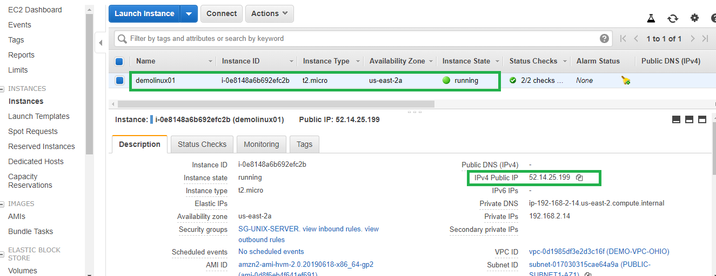

**Procedure for connecting Unix EC2 instance:**

1. Open Putty gen [Download if not available]
2. Click Load and select the downloaded pem key from step 9.

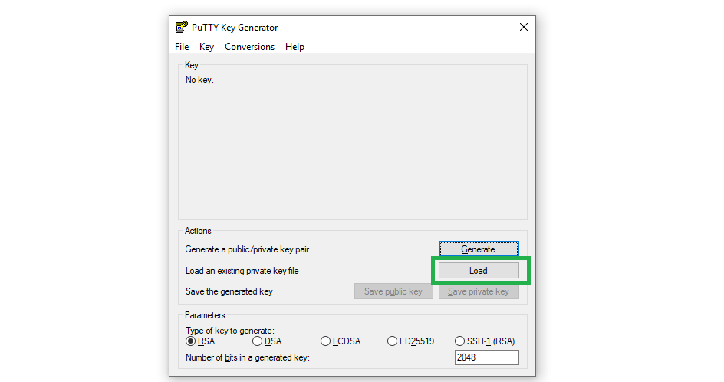

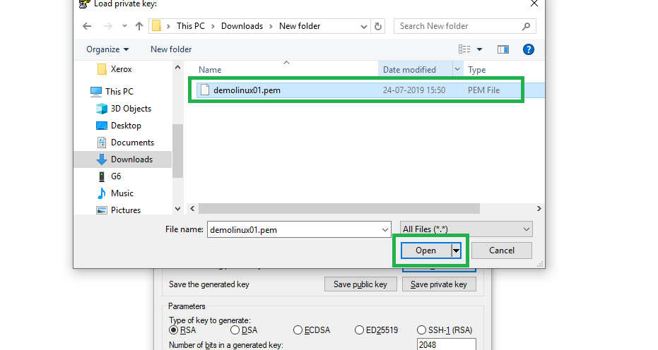

1. Once pem key is loaded you can see below message. Click ok.

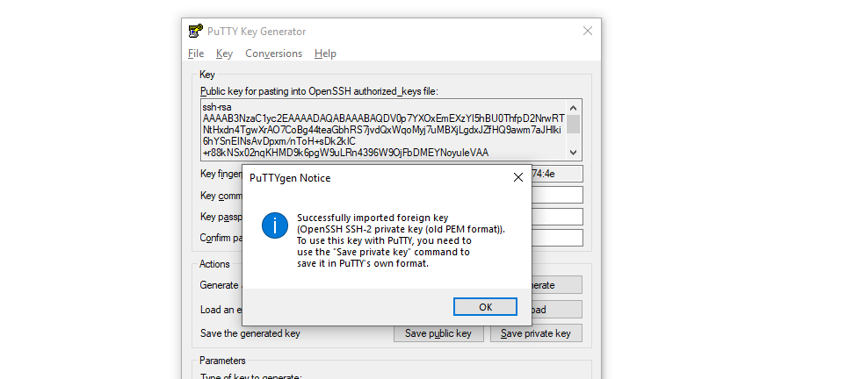

1. Click save private key and save it.

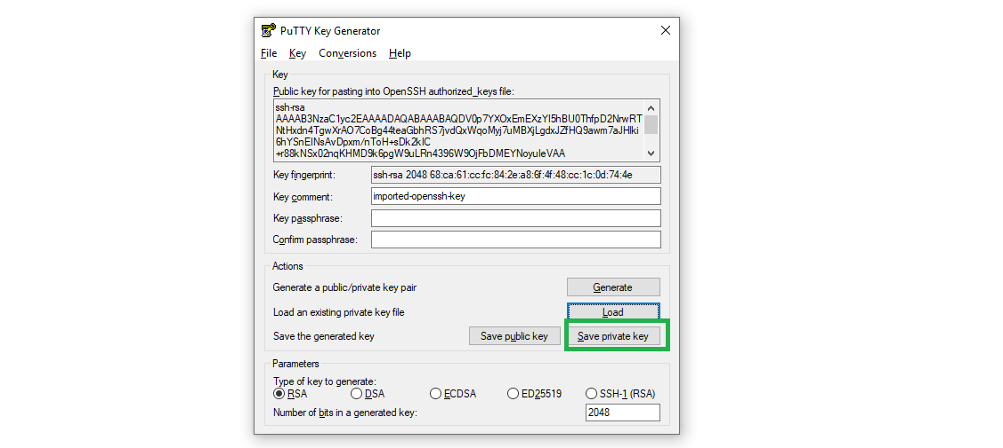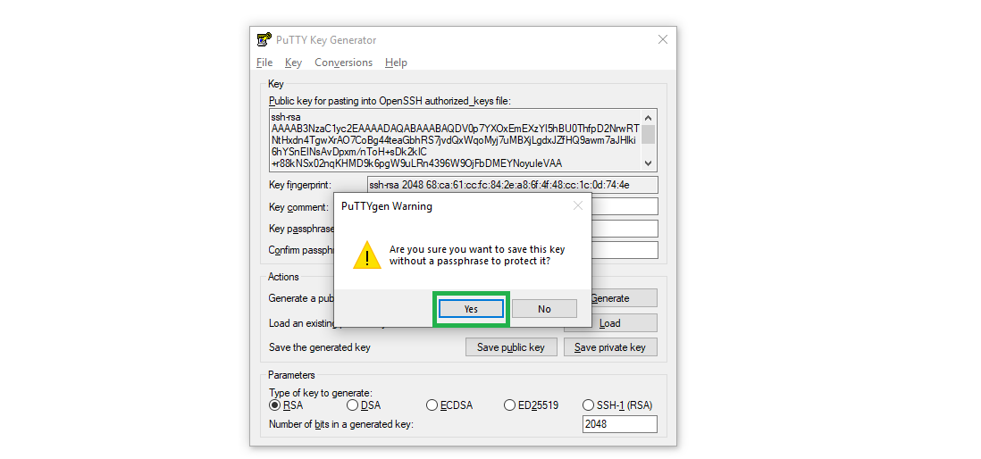

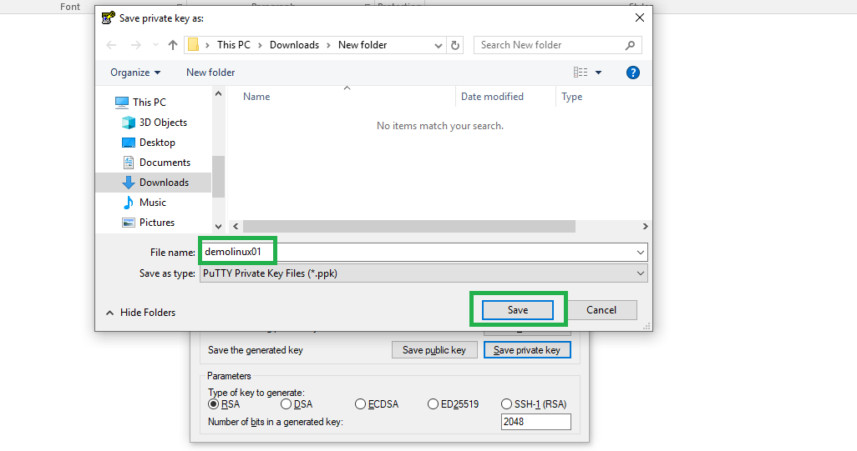

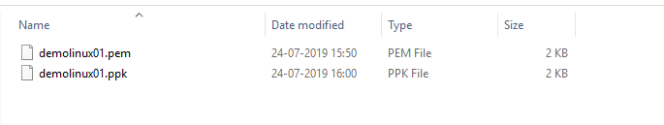

1. Open Putty [Download if not available]
2. In the hostname or IP address field select ec2-user@public ip of EC2 instance with port as 22 which is SSH port that we allowed in Security group.

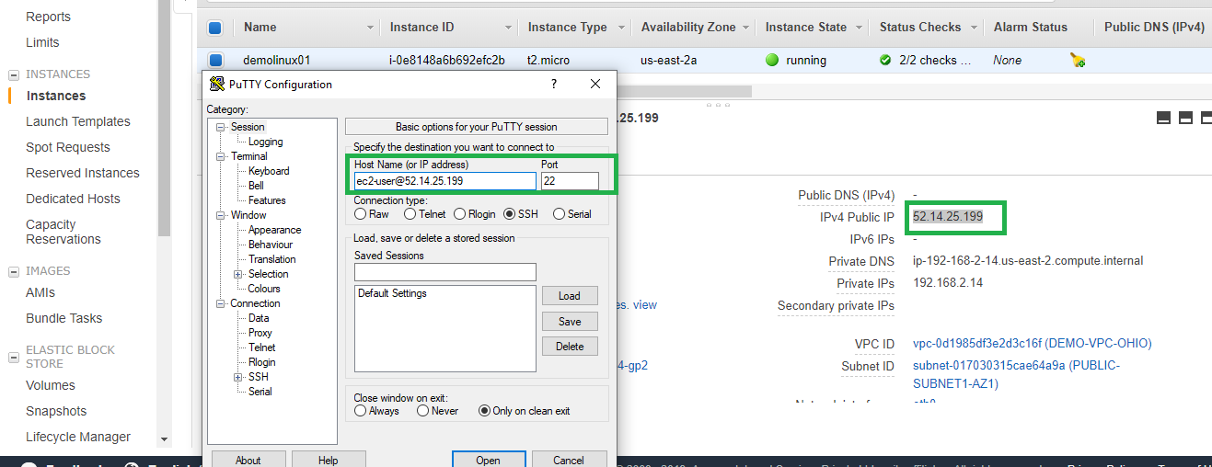

1. Select the SSH 🡪 Auth 🡪 browse and select the ssh private key that you saved and click open to connect to the EC2.

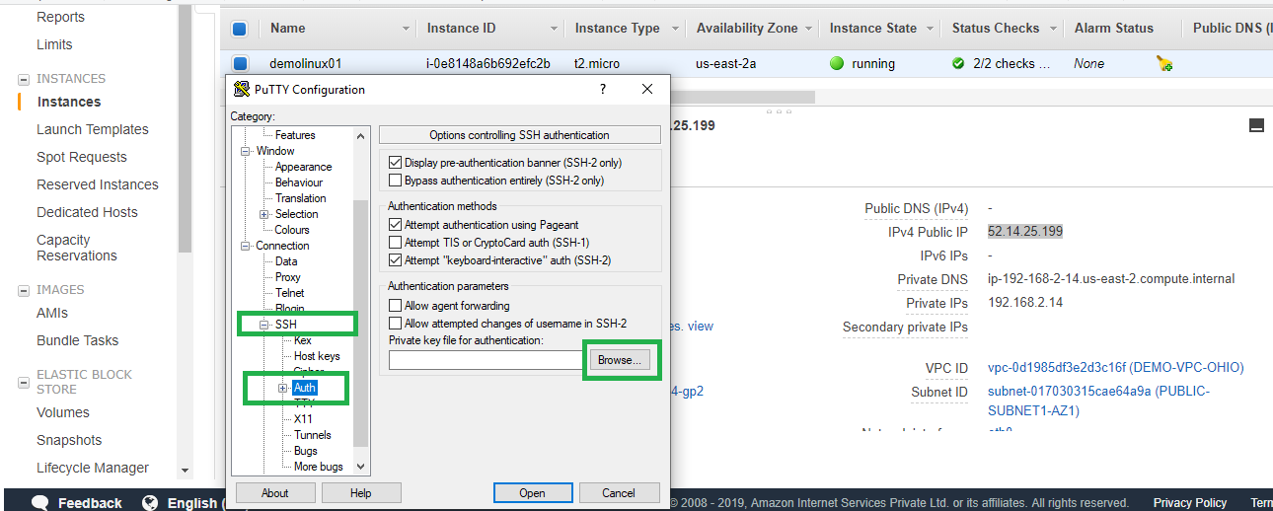

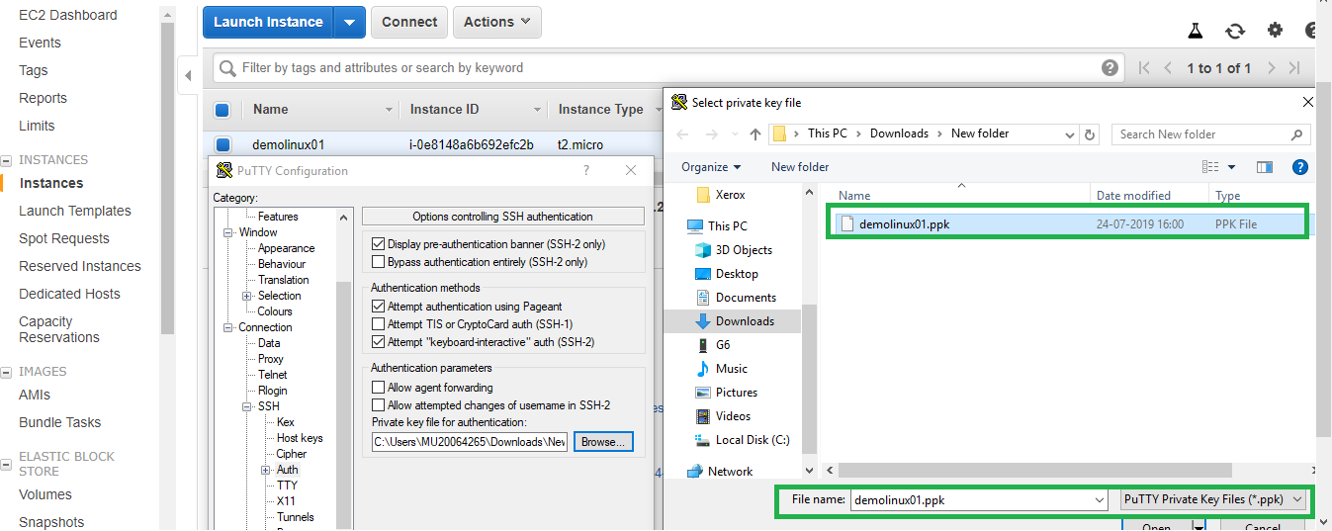

1. Click yes to login to the instance.

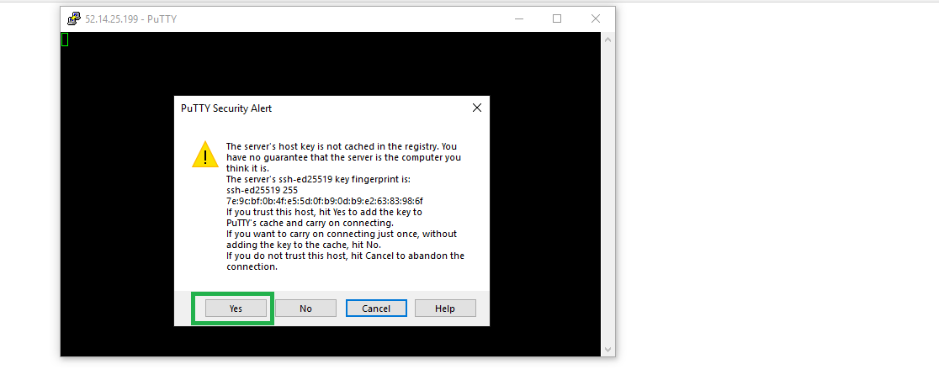

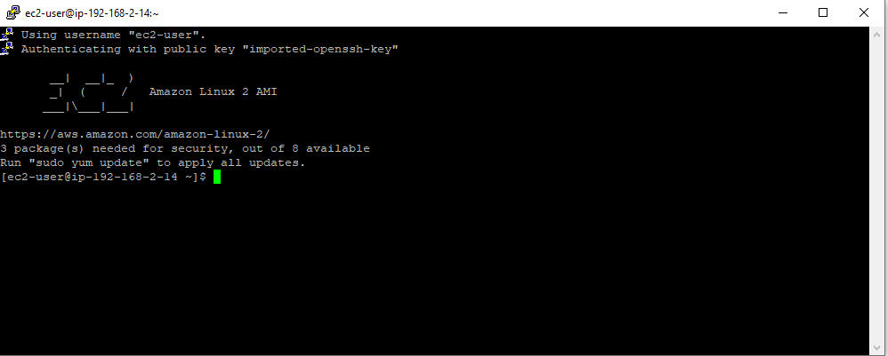

Also from the console you can click connect with browser based login with below procedure.

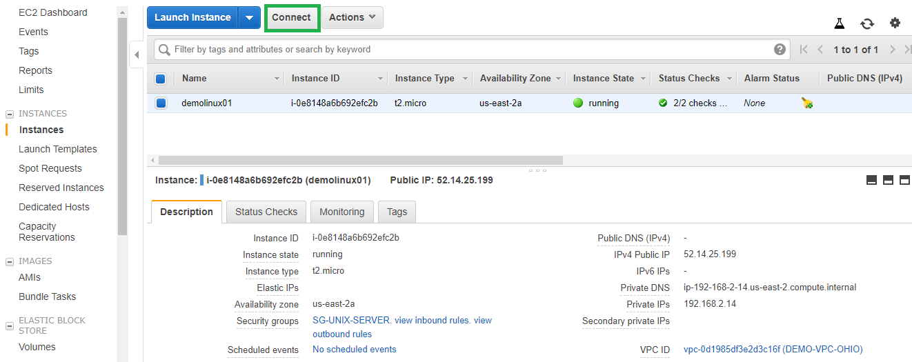

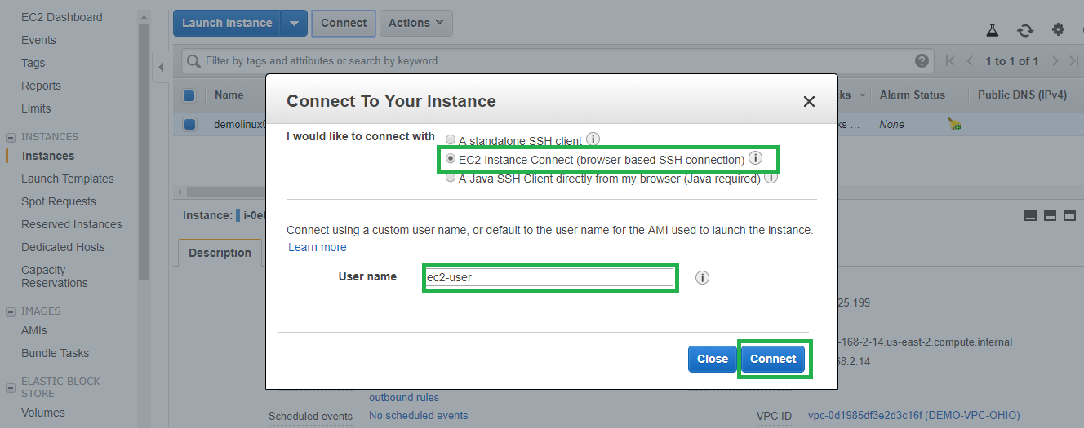

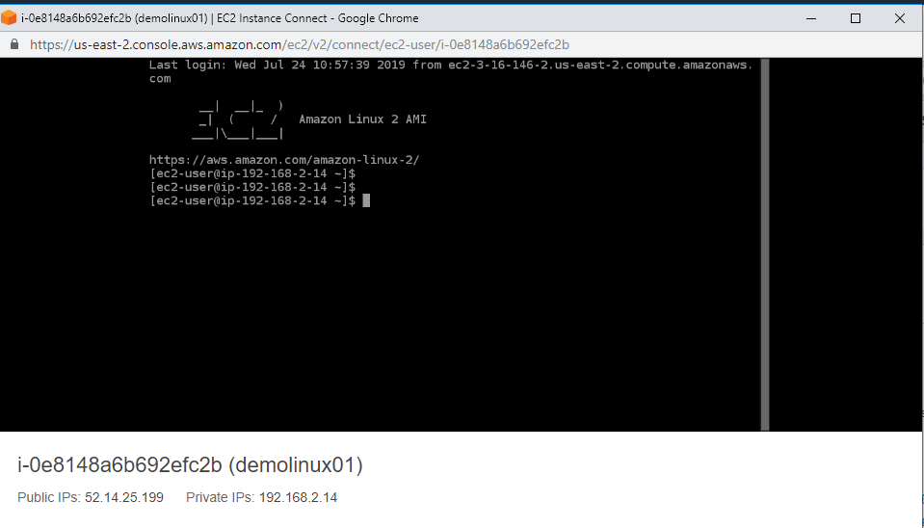

**Procedure for Windows based login:**

Follow the above procedure for launching a windows EC2 instance and make sure to select a windows Free tier AMI.

1. Launch a windows EC2 instance and download the key pair as similar as previous steps.

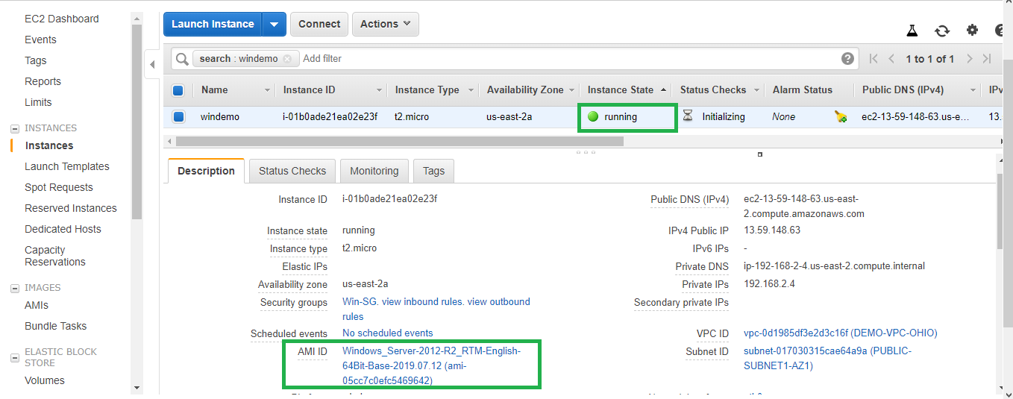

1. Select the windows instance and click connect.

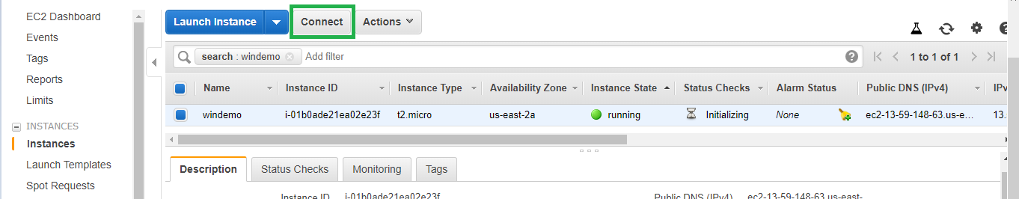

1. Click Download Remote Desktop File and save it.

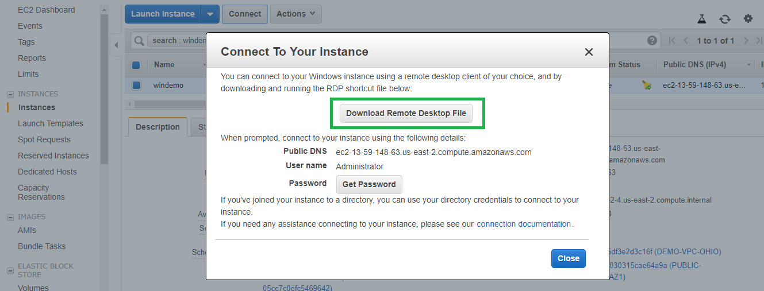

1. Click Get Password

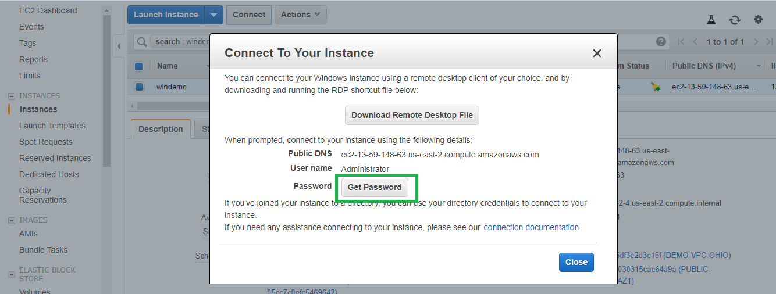

1. Click Choose File and select the downloaded pem file

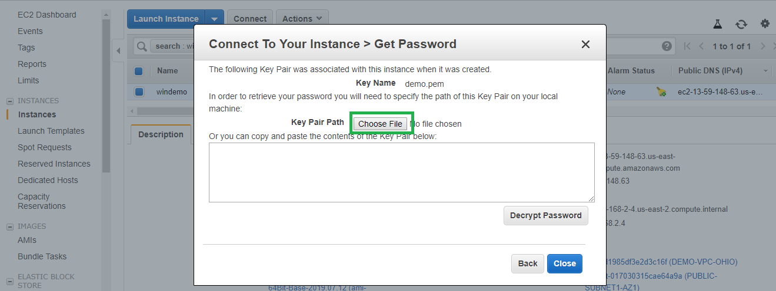

1. After selecting the key click on decrypt password. Ensure the key name shown and key name you selected are same.

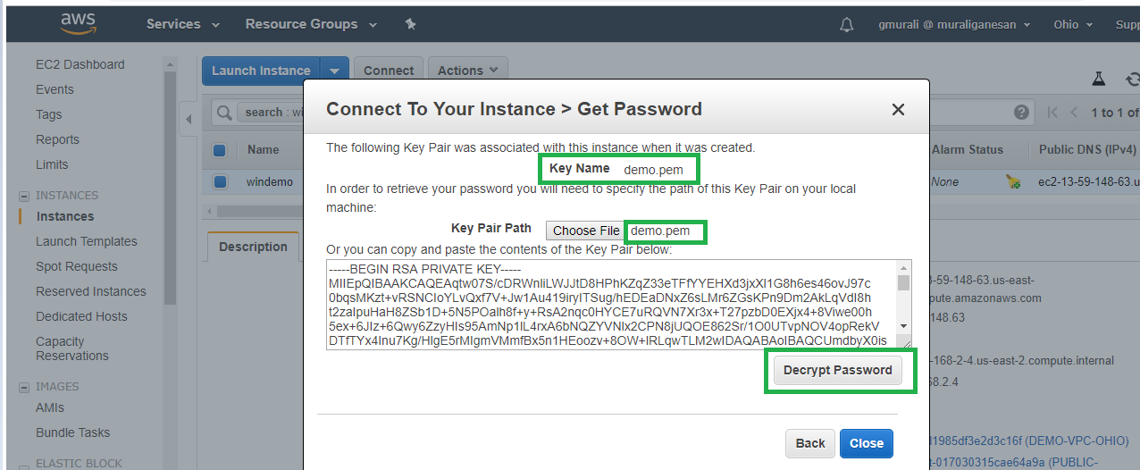

1. The Administrator password is shown and you can login to the windows EC2 with this password.

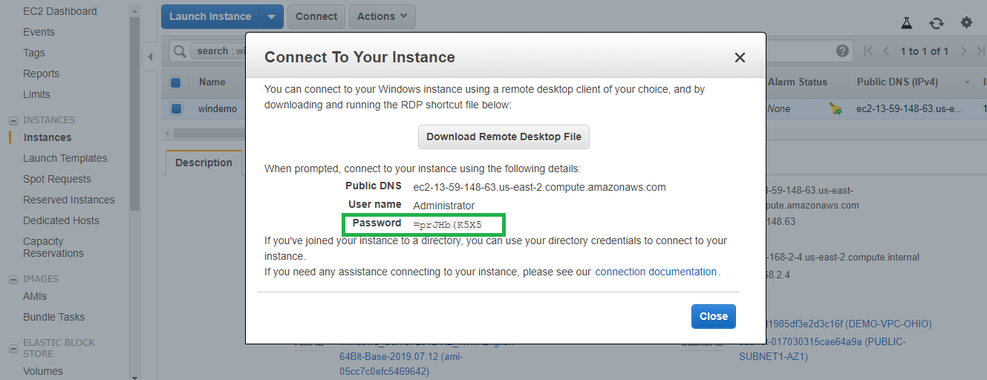

1. Double click the RDP file downloaded before and click connect

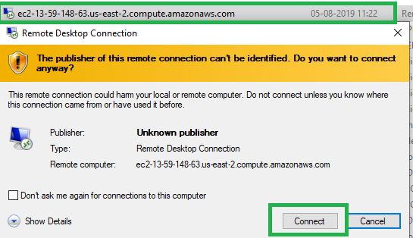

1. Provide the decrypted Administrator password to login to the instance and click yes to proceed.

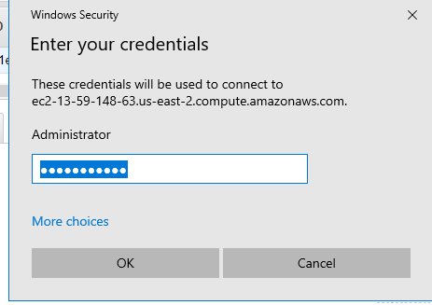

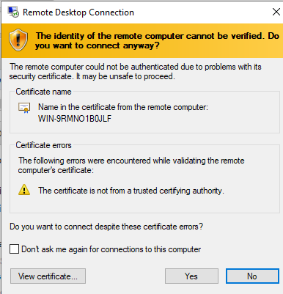

1. Wait for the login to complete.

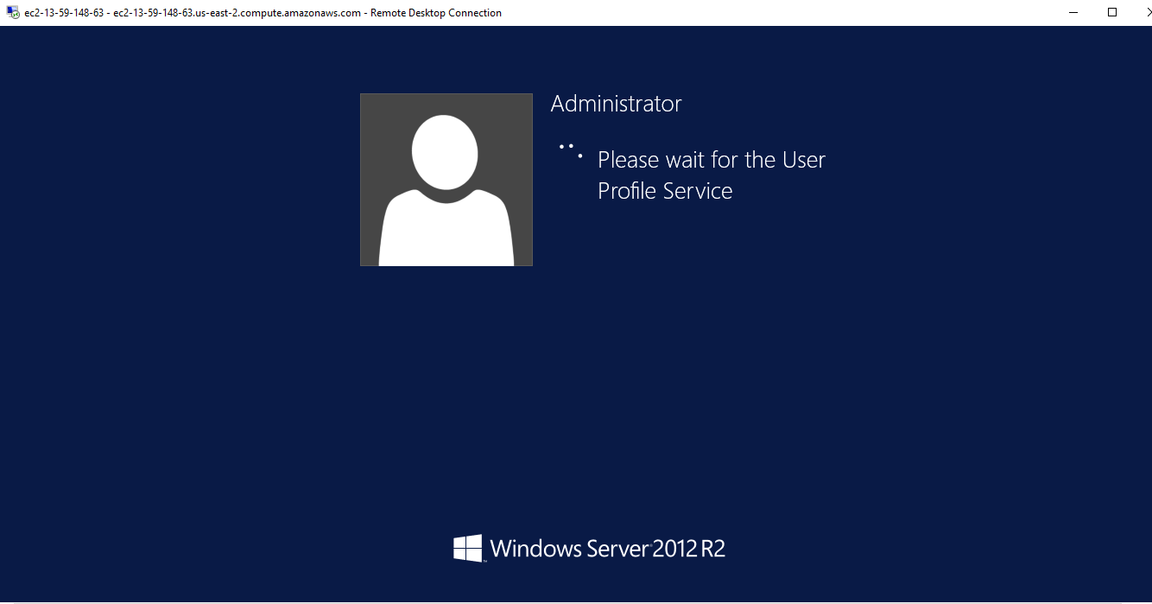

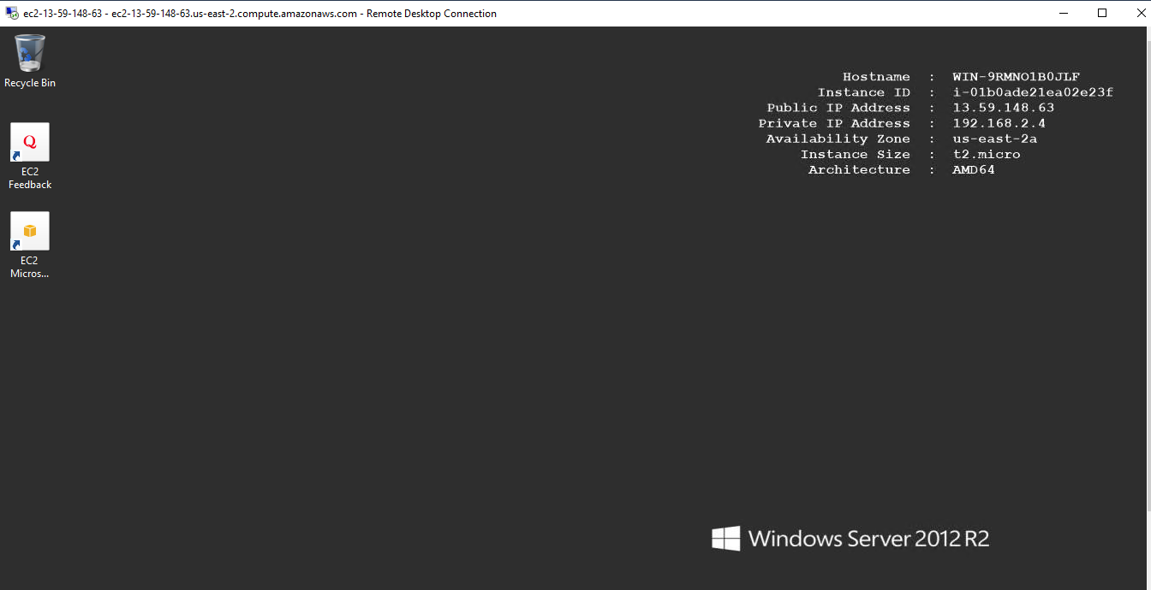

**Note: After completing the lab make sure to delete all the resources.**